RESOLUTION NO.__________

RE: CERTIFICATE OF APPROPRIATENESS UNDER THE
PROVISIONS OF THE ACT OF THE PENNSYLVANIA
LEGISLATURE 1961, JUNE 13, P.L. 282 (53
SECTION 8004) AND BETHLEHEM ORDINANCE NO.
3952 AS AMENDED.

WHEREAS, it is proposed to install a new post lamp, LED ground lights and a gutter on the garage at 129 E. Market St.

NOW, THEREFORE, BE IT RESOLVED by the Council of the City of Bethlehem that a Certificate of Appropriateness is hereby granted for the proposal.

Sponsored by: (s)

(s)

ADOPTED BY COUNCIL THIS DAY OF

(s)
President of Council

ATTEST:

(s)
City Clerk

HISTORICAL & ARCHITECTURAL REVIEW BOARD

The applicant proposes to install a lamp post in the front yard, LED lights on the stone wall & aluminum gutters on the garage at 129 E.
Market St.
APPLICATION #2:

Bruce & Kim Campbell
129 E. Market St., Bethlehem, PA 18018

OWNER:

__________________________________________________________________

The Board upon motion by Phil Roeder and seconded by Marsha Fritz adopted the proposal that City Council issue a Certificate of Appropriateness for the following:

- Install a new post lamp to illuminate the front walk.

- LED ground mounted lights to focus on the stone garden walls.

3. Brown half round gutter to be installed on the garage.

4. The motion was unanimously approved.

__________________________________________________________________________

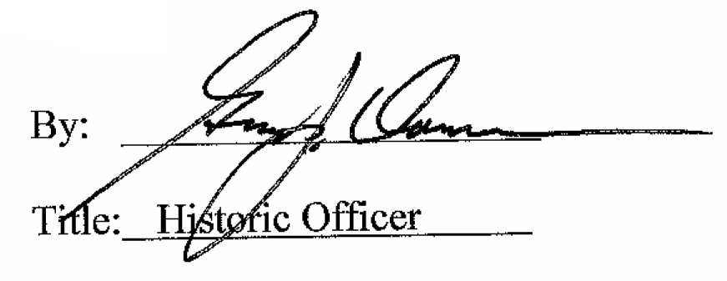

Date of Meeting: September 2, 2015

